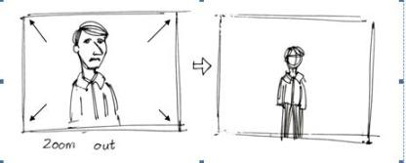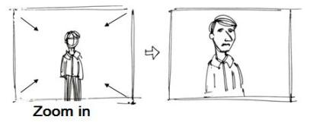

|  |  |  |
| --- | --- | --- |
| **B** | | **Story boards: Purpose** |
| 1 | Show how a moving visual product will look | |
| 2 | Help to plan camera positions, scenery, setting and props in production | |

|  |  |  |  |
| --- | --- | --- | --- |
| **A** | | | **Story boards: Content** |
| 1 | **Camera Shots** | | |
| 2 | **Camera Angles** | | |
| 3 | **Camera Movements** | | |
| 4 | **Scene content** (what’s happening) | | |
| 5 | **Annotations** (showing…) | | |
| 6 | | **Timings** | |
| 7 | | **Lighting effects** | |
| 8 | | **Sound effects** | |
| 9 | | **Location** | |
| 10 | | **Camera Type** | |

|  |  |  |
| --- | --- | --- |
| **C** | **Camera Vocab** | |
| **Camera Shots** | | |
| **Establishing shot** | | Wide angle including characters and setting |
| **Two shot** | | Shot including two characters in dialogue |
| **Close up** | | Shot of one character’s whole head |
| **Extreme close up** | | Shot of a particular detail (should be used sparingly) |
| **Camera Angles** | | |
| **Low angle** | | Shot from below, looking up at a character |
| **High angle** | | Shot from above, looking down at a character |
| **Mid angle** | | Shot showing the upper body and head of a character |
| **Wide angle** | | Shot including the whole body of a character |
| **Over shoulder** | | Shot with the back of a character’s shoulder and head in the foreground, putting the viewer in the scene |
| **Point of View** | | (normally hand held) shot as if the camera is the eyes of a character, putting the viewer in the position of the character |
| **Camera Movements** | | |
| **Zoom in** | | Camera stays still, but the image gets bigger |
| **Zoom out** | | Camera stays still, but the image gets smaller |
| **Pan** | | Camera stays still, but twists left or right |
| **Camera Type** | | |
| **Still** | | A still shot would not be moving |
| **Video** | | A normal moving image |
| **Virtual** | | An animated image |

Name:

R081: Story boards



|  |  |  |
| --- | --- | --- |
| **B** | | **Story boards: Purpose** |
| 1 | Show how a moving visual product will look | |
| 2 | Help to plan camera positions, scenery, setting and props in production | |

|  |  |  |  |
| --- | --- | --- | --- |
| **A** | | | **Story boards: Content** |
| 1 | **Camera Shots** | | |
| 2 | **Camera Angles** | | |
| 3 | **Camera Movements** | | |
| 4 | **Scene content** (what’s happening) | | |
| 5 | **Annotations** (showing…) | | |
| 6 | | **Timings** | |
| 7 | | **Lighting effects** | |
| 8 | | **Sound effects** | |
| 9 | | **Location** | |
| 10 | | **Camera Type** | |

Name:

R081: Story boards

|  |  |  |
| --- | --- | --- |
| **C** | **Camera Vocab** | |
| **Camera Shots** | | |
| **Establishing shot** | | Wide angle including characters and setting |
| **Two shot** | | Shot including two characters in dialogue |
| **Close up** | | Shot of one character’s whole head |
| **Extreme close up** | | Shot of a particular detail (should be used sparingly) |
| **Camera Angles** | | |
| **Low angle** | | Shot from below, looking up at a character |
| **High angle** | | Shot from above, looking down at a character |
| **Mid angle** | | Shot showing the upper body and head of a character |
| **Wide angle** | | Shot including the whole body of a character |
| **Over shoulder** | | Shot with the back of a character’s shoulder and head in the foreground, putting the viewer in the scene |
| **Point of View** | | (normally hand held) shot as if the camera is the eyes of a character, putting the viewer in the position of the character |
| **Camera Movements** | | |
| **Zoom in** | | Camera stays still, but the image gets bigger |
| **Zoom out** | | Camera stays still, but the image gets smaller |
| **Pan** | | Camera stays still, but twists left or right |
| **Camera Type** | | |
| **Still** | | A still shot would not be moving |
| **Video** | | A normal moving image |
| **Virtual** | | An animated image |